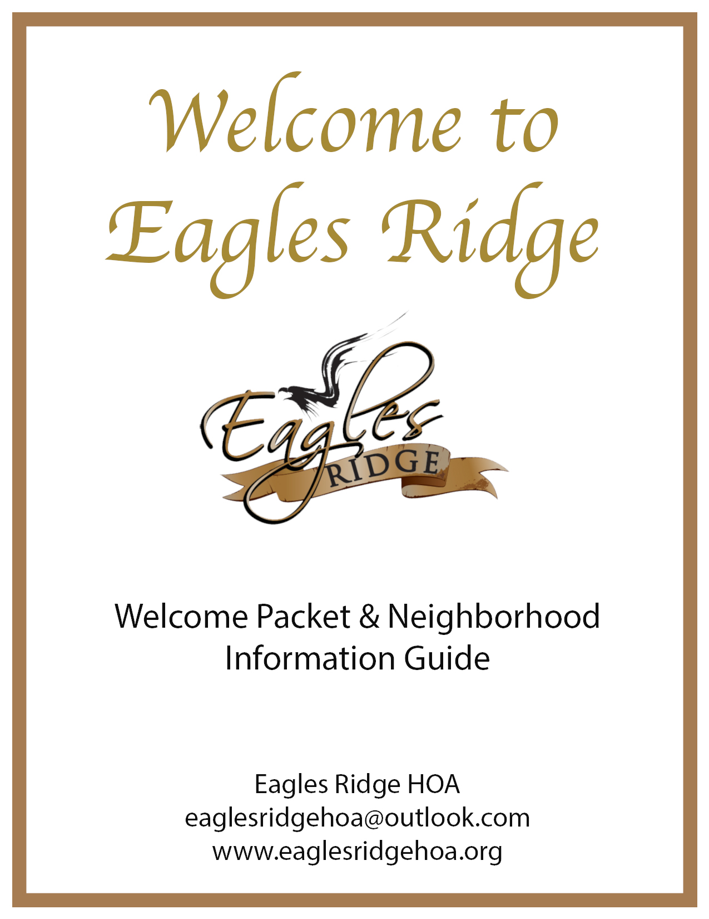

We are so happy to have in our neighborhood! Here are some important things you should know about. Please look through them at your leisure as we completely understand how crazy moving can be. Please reach out to the HOA if you ever need anything or have any questions/concerns.

If you are the homeowner, you will need to create a login for the exclusive members only area on our website! The member’s only area is where you will find all official
communications from the HOA to all homeowners of Eagle’s Ridge Single Family Homes and Eagle’s Ridge Estates. This will also give the HOA your contact information to enroll you into HOALife and receive our monthly newsletters by email. Our meetings, budget, committees/groups, events calendar, invoicing, and more are all available through this exclusive area. Please find step by step directions in this packet and also on our website: Eaglesridgehoa@outlook.com

Frequently Answered Questions

- Which trash service must I use?
All homes are required to use Lies Trash Service for trash, recycling, and/or yard waste. You will need to call in order to get the HOA discount. Trash days are weekly on Thursdays.

- How do I know if I owe any dues / fees?
Let the HOA know you are new to the neighborhood by emailing us at eaglesridgehoa@outlook.com

- How do I pay my dues / fees? Are they due annually?
You can pay through our website or mail a check to 4800 SW 3rd Street Blue Springs, MO 64014. Make checks payable to Eagle's Ridge Single Family Homes Association. Dues are paid annually, and invoices will be emailed out to homeowners at the beginning of the year through the members only area on our website. If you would like them mailed, please send us an email requesting such.
- What is included with our dues / fees?
Dues and fees are used towards common area maintenance (mowing, trimming, lawn treatments, mulching, sprinklers, etc.) for the front entry, the area around the retaining pond on Chelmsford, and the pool area. Pool maintenance including chemicals, salt, maintenance needed, and work to maintain a great community pool for our members. Utilities for the pool area, legal fees, insurance, and property taxes are also paid with dues and fees collected. Once completed by the developer, the other retention ponds, common areas, and walking trails will be maintained as well by the HOA. Trash is not included in the yearly dues.

- Where are the HOA restrictions at?
A copy of the rules and restrictions are located on the HOA website.

- What type of mailbox do I get? Where do I put it?
If you are one of the original 44 homes, you can choose what type of mailbox you would like and install. This relates to the original 44 homes in Eagle’s Ridge only. All new build homes in Eagle’s Ridge will utilize a community mailbox.

- I need to get access to my community mailbox; how do I do that?
When you close on your home, you will need to take a document with your home address information (Deed is the most common) to the Blue Springs USPS at 500 SW South Ave. BS, MO 64014. They will assign you a mailbox and give you keys to access your mailbox. Free standing mailboxes for the new homes are not permitted.

- How do I communicate with the HOA?
Feel free to email us anytime! You can contact us by e-mail at eaglesridgehoa@outlook.com or message us though the members only area on our website using the Member Chat button. We do not have, nor use, any HOA phone number. There is also a Facebook group page, (Request to join the group Eagle’s Ridge Subdivision in Blue Springs, MO) that you can ask questions on if they are general / social types of questions and not personal.

- When is the next HOA meeting?
Starting in 2022, meetings will be held quarterly in February, May, August, and November. They will be announced through the members only area on our website and through the emailed monthly newsletters. Please join us on our website so you never miss any important news, updates, and events!

- Are there any events that are neighborhood wide?
We will post upcoming events in the Events Calendar found in the members only area on our website and through the emailed monthly newsletters. Please join us on our website so you never miss any important news, updates, and events! We try to have neighborhood garage sales and block parties at least once per year.

- What do the pool key fobs look like?
- Key fob(s) were left when I moved in, what do I do? I don’t have any fob(s), what do I do?
Please contact the HOA and let them know you have the key fob(s) or if you need yours. Fill out the pool application, physically sign the release, and return by scanning them to the HOA email or through the Member Chat on the website. Please see the paper forms in this packet or on our website. If you don’t have a scanner, you can take a clear picture and send it that way as well. The key fobs will be activated and turned on after all requirements are met. HOA dues / fees must be verified as paid in full.

- The pool fountains are not on, how do I turn them on?
The pool fountains and kids spray accessories are on a timer to work only during certain hours. On windy days they are sometimes turned off to save water from washing out of the pool. There is a button on the wall by the pool house door that, when pushed in, will activate them for a short period. It takes the pump at least 60 seconds to switch over. Please monitor your kiddos so they are not pushing the button repeatedly. If the fountains do not turn on within a minute, please do not keep pushing the button as it will overload the pump and cause it to shut down.
- Who can utilize the pool?
Eagle’s Ridge Single Family Homes and Eagles Ridge Estates only have access to our pool at 4800 SW 3rd Street. The multi-family housing does not have access to utilize the zero-entry pool as they have the one by the front entrance. Dues / fees must be paid before utilizing the pool. Please do not let others follow you in through the gate, hold the door open for others, or let people in that lost their key. This creates increased liability if they are not allowed to be there. If you see any suspicious behaviors or have any negative experiences while utilizing the pool, please contact the HOA as soon as possible.

- I want to install a fence, or paint my door / exterior, or stain my old fence. What should I do?
Please review the CC&Rs to review types of fences approved (height, placement, & materials). All changes to your exterior residential lots require documented requests to the HOA. These requests all go through the ARC Committee for approval. New in June 2022, the HOA is using HOALife for all ARC requests, complaints, and violations. You will receive instructions on how to use this program in this packet. Please reach out if you have any questions or problems with this new program.

- What are the most common complaints that the HOA receives?
Trash not being picked up from construction crews, new construction noise/trash in the neighborhood, developer not completing and not mowing the undeveloped tracts, RVs and Boats parked on driveways and streets, landscaping / lack of lawn maintenance, and barking dogs.

- I have a question not answered above, what should I do?
Send an e-mail to the HOA at eaglesridgehoa@outlook.com and we’ll respond as soon as possible!

EAGLES RIDGE HOA

Application for Pool Use and Release of Reliability

Name: Email:
(Homeowner)

Name: Email:
(Co-Owner)

Address:

Phone Number: ( ) Alt Phone: ( )

Additional Family Members that live in the home:

Name: DOB Name: DOB

Name: DOB Name: DOB

Name: DOB Name: DOB

Pool Rules:
Pool Hours:
8am to 9pm Sunday thru Thursday
8am to 11pm Friday and Saturday

- NO LIFEGUARD ON DUTY. All persons using the pool do so at their own risk.
- Children under 13 must be accompanied by an adult at all times. Not an older sibling.
- NO DIVING.
- Proper swim attire must be worn at all times. Swim diapers must be used for all non-toilet trained kiddos.
- NO GLASS or alcoholic beverages in pool area.
- NO PETS allowed in pool area with the exception of guide animals.
- NO SMOKING.
- NO GRILLING.
- No more than 4 guests per household. Homeowner must accompany guests at all times.
- Do not let unknown people follow you into the pool. Let everyone use their own key to enter.
- Do not move tables and furniture.
- Please pickup after yourself before leaving.
- Please be respectful of others in the pool.

**All HOA dues must be paid and in current standing to use the pool**

Pool Key Fobs:
- Key fobs belong to the HOA, not the homeowner. Therefore, key fobs must be returned to the HOA BEFORE you move out of the neighborhood.
- Lost key fobs must be replaced by the homeowner for $20 per fob. The HOA requires at least 48 hours’ notice for key fob replacement and activation.

Assumption of Risk:
I, the undersigned, wish to use the pool owned by Eagles Ridge HOA; I recognize and understand using Eagles Ridge HOA pool involves risk of injury to me or my guest, whether I or someone else causes it. Specific risks vary from one activity to another, and the risks range from minor injuries to catastrophic injuries, including death.

Release of Liability and Wavier:
- I understand the Rules for using Eagles Ridge HOA pool and will abide by them.
- I understand and accept all risks including, but not limited to, the risk of injury resulting from possible malfunction of equipment used in the operation of the facilities and injuries resulting from tripping or falling over obstacles on the grounds and;
- TO WAIVE ANY AND ALL CLAIMS that I have or may in the future have against Eagles Ridge HOA, and each of their respective officers, directors, volunteers, agents, and independent contractors (all of whom are hereinafter referred to as “the Releasees”);
- TO RELEASE THE RELEASEES from any and all liability including, without limitation, any loss, damage, injury, or expense that I may suffer or that my next of kin may suffer as a result of my participation at Eagles Ridge HOA pool due to any cause whatsoever, including any ordinary or gross negligence, active or passive, of the Releasees or anyone acting on the Releasees behalf or anyone using the facilities whether related to my participation or not.
- TO INDEMNIFY, DEFEND AND HOLD HARMLESS THE RELEASEES against any liability, damages, defense costs, including attorneys’ fees, and any other costs incurred in connection with claims for bodily injury, wrongful death, or property damage, to any third party, resulting from my, or my guest participation at Eagles Ridge HOA pool, negligence or other wrongful acts or omissions.

BY SIGNING BELOW, I ACKNOWLEDGE AND AGREE THAT I HAVE READ AND UNDERSTAND THE FOREGOING AND KNOW THE NATURE OF THE ACTIVITIES AT EAGLES RIDGE HOA POOL AND I AM WAIVING CERTAIN LEGAL RIGHTS WHICH I OR MY HEIRS, NEXT OF KIN, EXECUTORS, ADMINISTRATORS AND ASSIGNS MAY HAVE AGAINST THE RELEASEES.

Homeowner Signature/Date Co-Owner Signature/Date

*Updated 2022
Eagles Ridge HOA Pool Property Rules and Regulations

Pool Hours:
8am to 9pm Sunday thru Thursday
8am to 11pm Friday and Saturday

- NO LIFEGUARD ON DUTY. All persons using the pool do so at their own risk.

- Children under 13 must be accompanied by an adult at all times.

- NO DIVING.

- Proper swim attire must be worn at all times. Swim diapers must be used for all non-toilet trained kiddos.

- NO GLASS or alcoholic beverages in pool area.

- NO PETS allowed in pool area with the exception of guide animals.

- NO SMOKING.

- NO GRILLING.

- No more than 4 guests per household. Homeowner must accompany guests at all times.

- Do not let unknown people follow you into the pool. Let everyone use their own key to enter.

- Do not move tables and furniture.

- Please pickup after yourself before leaving.

- Please be respectful of others in the pool.

*All HOA dues / fees must be paid and in current standing to use the pool*

A $20 fee will be charged for lost pool access keys

EMERGENCY NUMBER: 911
NON-EMERGENCY: 816-228-0150

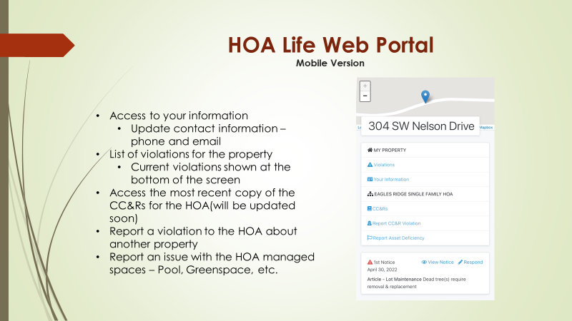
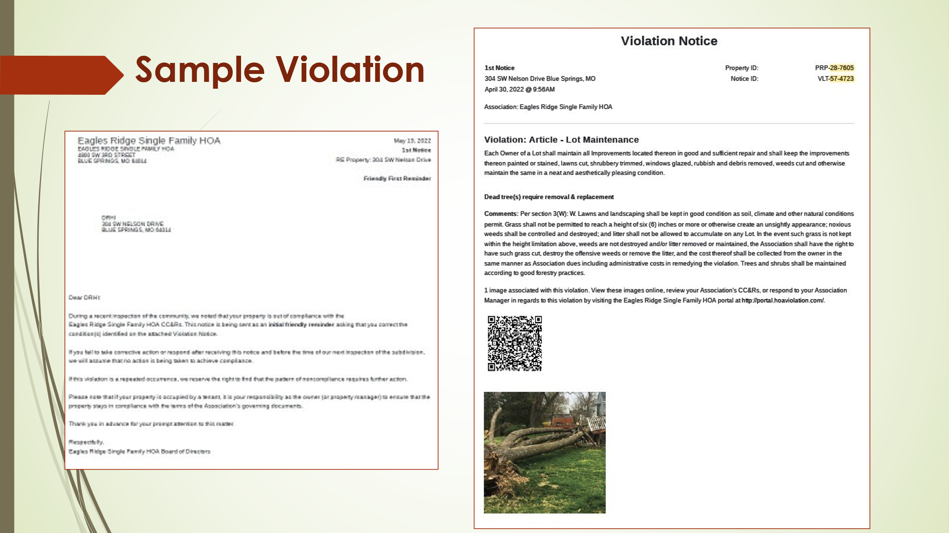
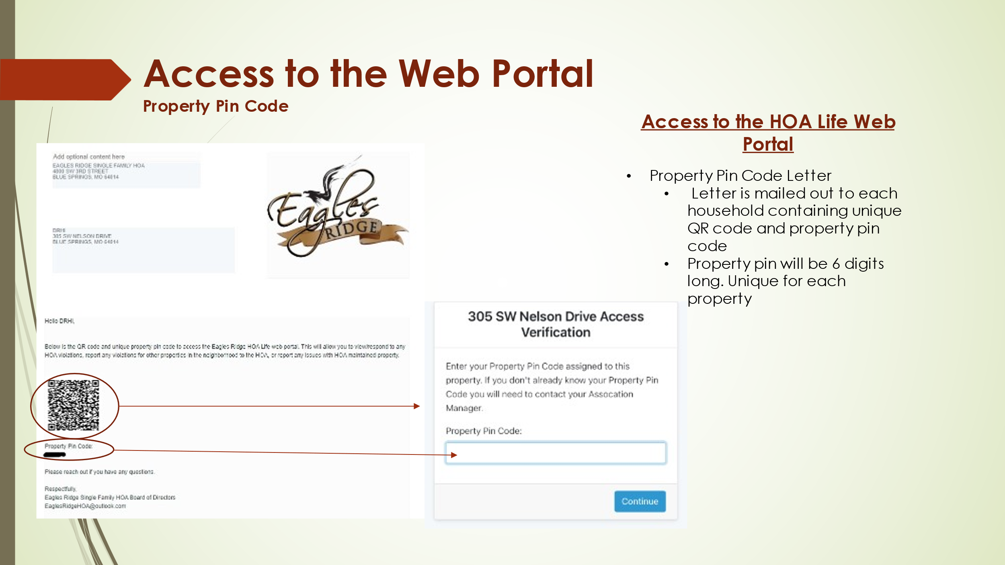
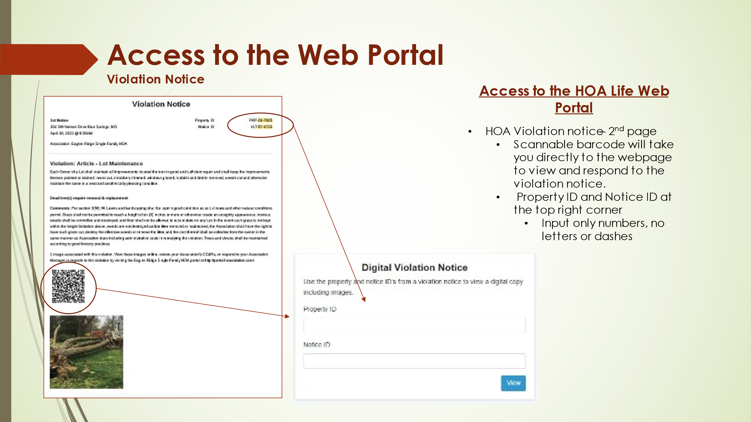
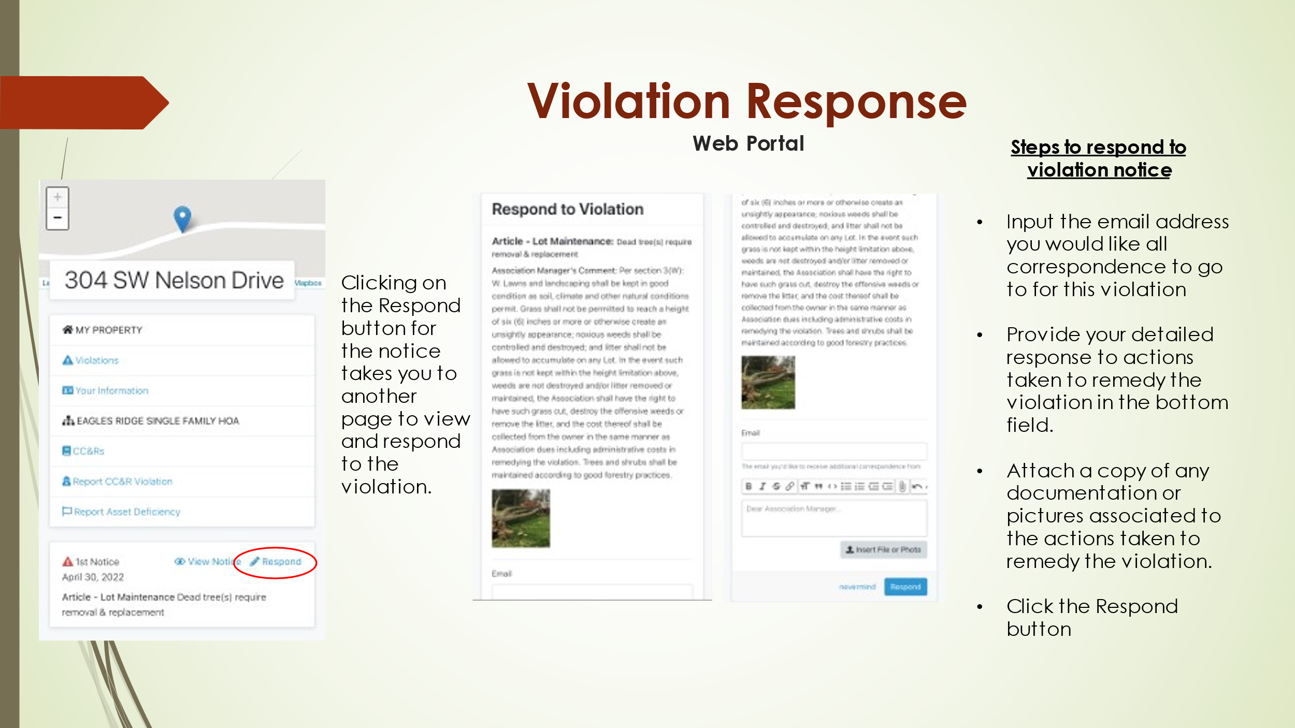
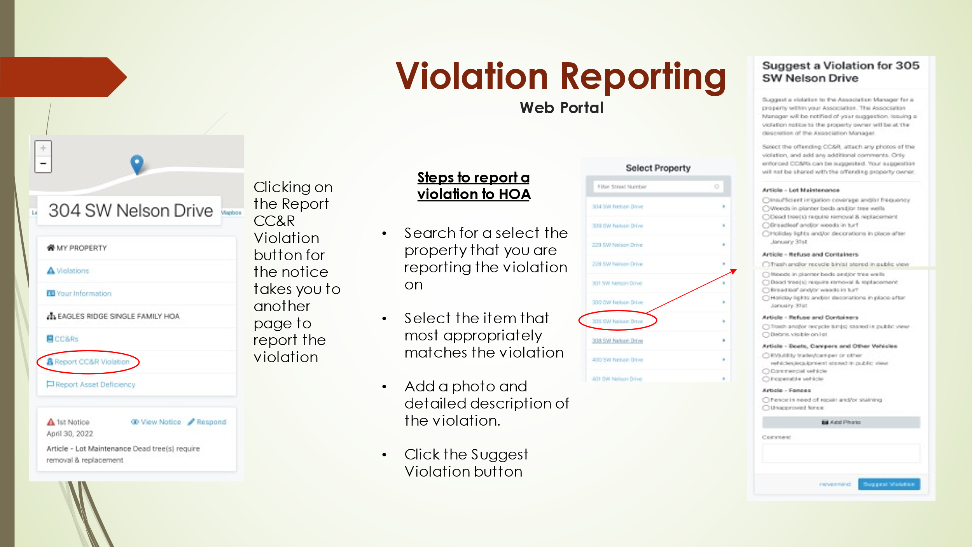
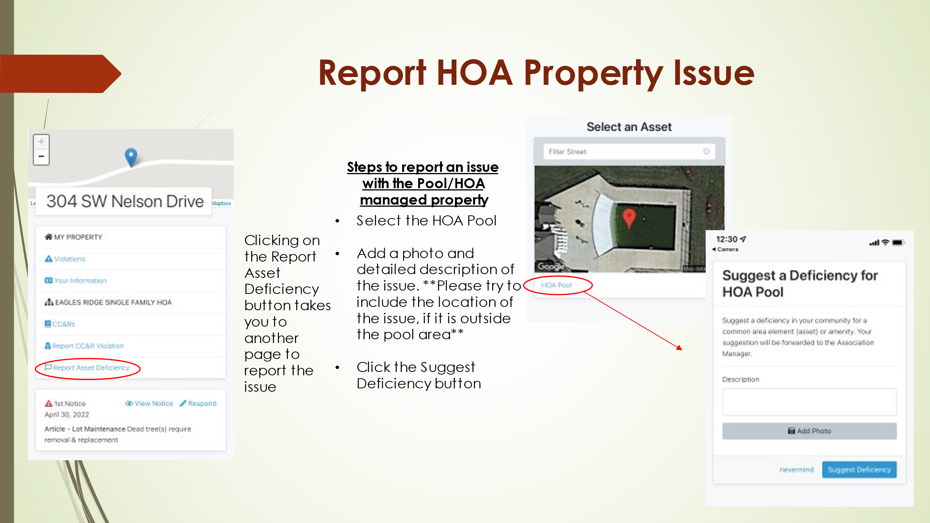
Please visit the HOALife page on our website for a login link to HOALife and for more details. If your letter with your home’s Pin# and QR code are not enclosed, you will be receiving them in the mail soon. Please reach out to the HOA by email or through the Member Chat on our website.

